**Abdul Aziz Mir**

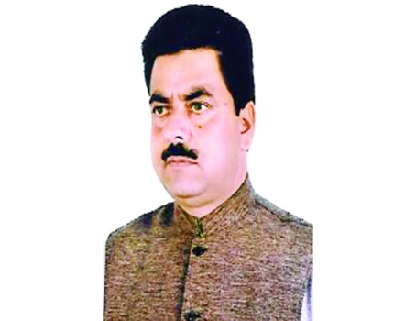

**About:** An MLA of Jammu and Kashmir''s ruling People’s Democratic Party (PDP) was shot dead in his home village of Konibal on Friday evening. A lone killer put a single bullet through 55-year-old Abdul Aziz Mir''s chest as he met people after Friday prayers at the central mosque in the village. The MLA was rushed to the sub-district hospital in Pampore and from there to Srinagar’s SMHS Hospital, where he was declared dead. The killer escaped in the melee immediately after the shooting. Mir’s personal security officer did not have a chance to react. An unknown militant outfit called the Save Kashmir Movement has claimed responsibility, and threatened a similar fate for everyone who worked to strengthen Indian rule in Kashmir. Mir is the first MLA to be murdered since Chief Minister Mufti Mohammad Sayeed’s PDP-Congress government came to power in the state. A large number of Mir’s electors thronged the slain MLA’s home in the evening. A veteran National Conference (NC) leader.

**Murdered on:** 20 December 2002.

**Attack details:** : An MLA of Jammu and Kashmir''s ruling People’s Democratic Party (PDP) was shot dead in his home village of Konibal on Friday evening. A lone killer put a single bullet through 55-year-old Abdul Aziz Mir''s.

**Reason to him target:** An unknown militant outfit called the Save Kashmir Movement has claimed responsibility, and threatened a similar fate for everyone who worked to strengthen Indian rule in Kashmir.

**Occupation:** Abdul Aziz Mir, MLA and PDP leader at Pampore in Kashmir.

**Belief** **:** MLA Mir who worked to strengthen Indian rule in Kashmir.

**URL:**<https://www.telegraphindia.com/india/mla-bleeds-at-mosque-door-militants-deal-another-blow-to-mufti-s-healing-touch/cid/849440>

<https://www.telegraphindia.com/india/mla-bleeds-at-mosque-door-militants-deal-another-blow-to-mufti-s-healing-touch/cid/849440>